NAME: S. DHARANI
REG NO: 192472364
COURSE CODE: DSA0401
NUMPY / PANDAS ANALYSIS – QUESTIONS AND ANSWERS
QUESTION 20: A/B TEST COMPARISON OF WEBSITE DESIGNS
AIM:
To test whether the mean conversion rates of website designs A and B are significantly different.
ALGORITHM:
1. Import NumPy and SciPy stats.
2. Enter conversion-rate observations for designs A and B.
3. Calculate the mean of each group.
4. Perform an independent two-sample t-test.
5. Compare the p-value with 0.05 and print the conclusion.
CODE:
import numpy as np
from scipy import stats
design_A = np.array([4.2, 4.5, 4.1, 4.4, 4.3, 4.6, 4.2, 4.5])
design_B = np.array([5.1, 5.3, 5.0, 5.4, 5.2, 5.5, 5.1, 5.3])
t_stat, p_value = stats.ttest_ind(design_A, design_B)
print("Mean A:", np.mean(design_A))
print("Mean B:", np.mean(design_B))
print("P-value:", p_value)
if p_value < 0.05:
print("Significant difference")
else:
print("No significant difference")
INPUT:
Sample conversion rates for designs A and B are included in the code.
OUTPUT:
Mean A: 4.35
Mean B: 5.2375
P-value: less than 0.05 (approximately)
Significant difference
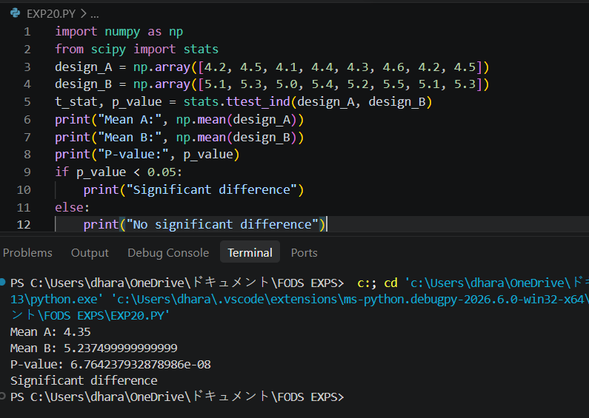
RESULT:
The t-test was performed and the sample data shows a statistically significant difference.

